1. COPY THE DATA FROM SERVER 1, DB 1, TABLE A TO SERVER 2, DB2, TABLE X

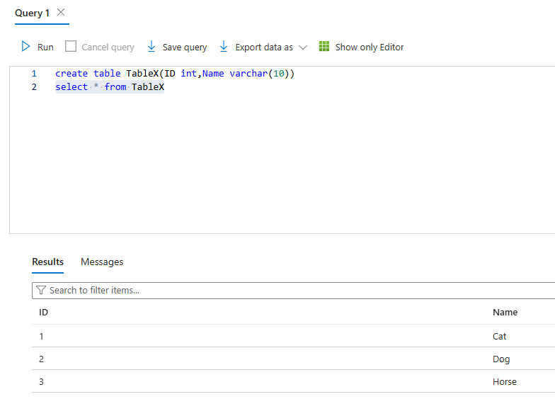

1. COPY THE DATA FROM SAME CONTAINER, FOLDER 1 TO FOLDER2

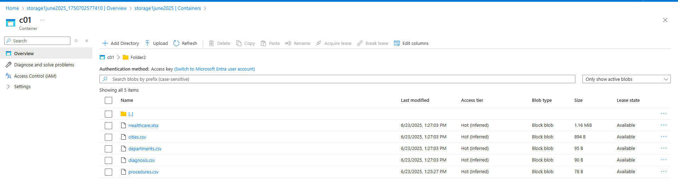

1. COPY THE DATA FROM CONTAINER1, FOLDER1 TO CONTAINER 2 FOLDER 2

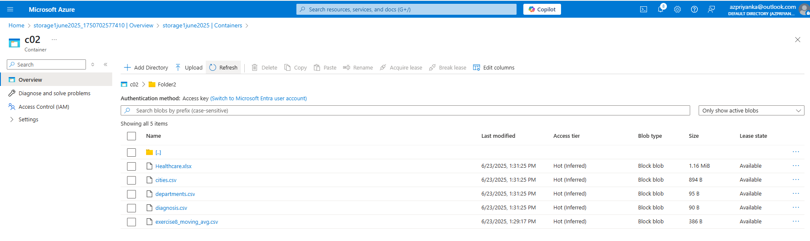

1. COPY THE DATA FROM CONTAINER1, FOLDER1, FILE1 TO CONTAINER2, FOLDER2, FILE2

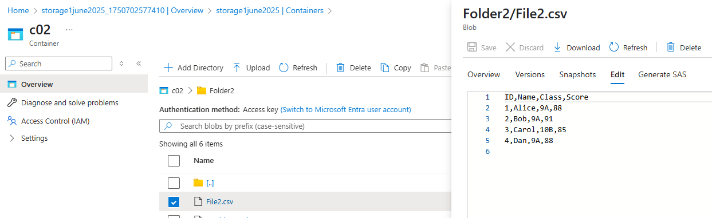

1. COPY THE DATA FROM ONE STORAGE ACCOUNT TO ANOTHER STORAGE ACCOUNT

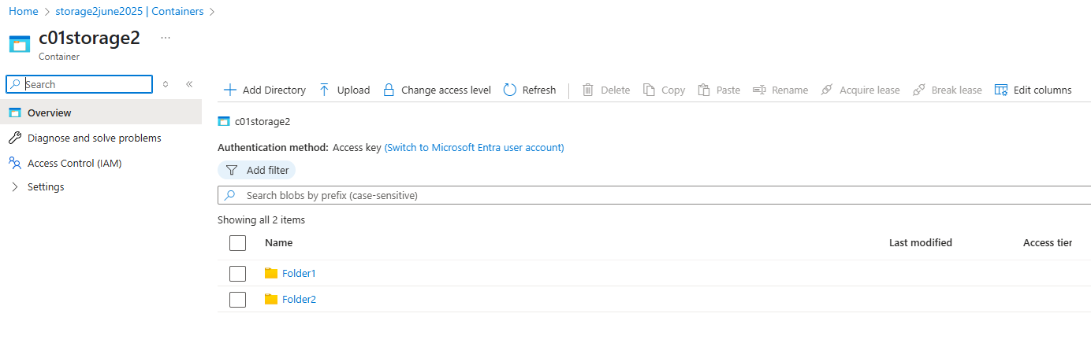

---

BLOB TO SQL COPY -- SINGLE FILE

**Outputs:**

**Copy from blob to Sql:**

**In Container:**

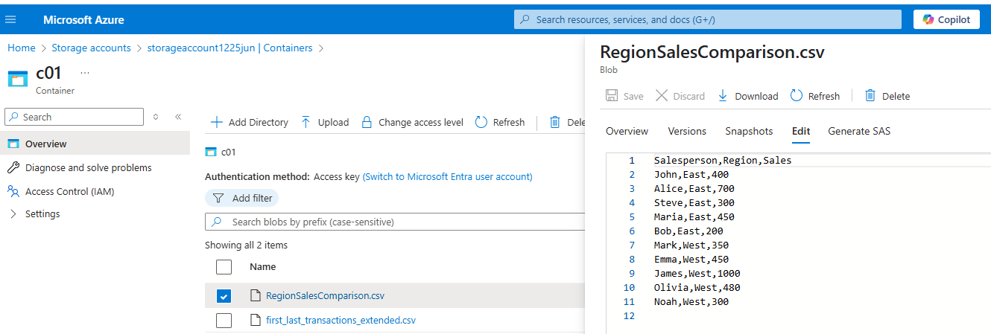

**In SSMS:**

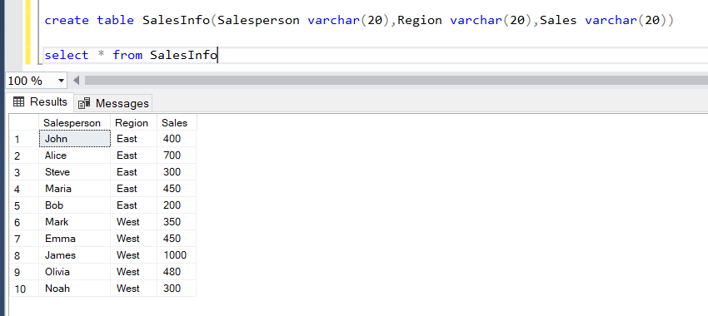

SQL TO BLOB COPY -- SINGLE FILE

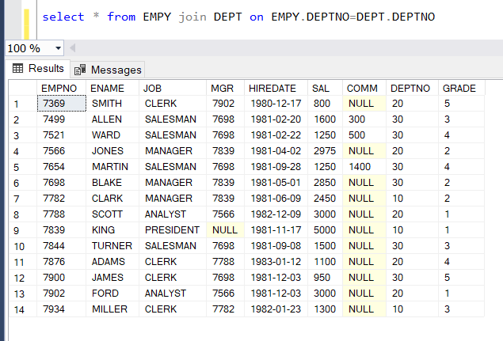

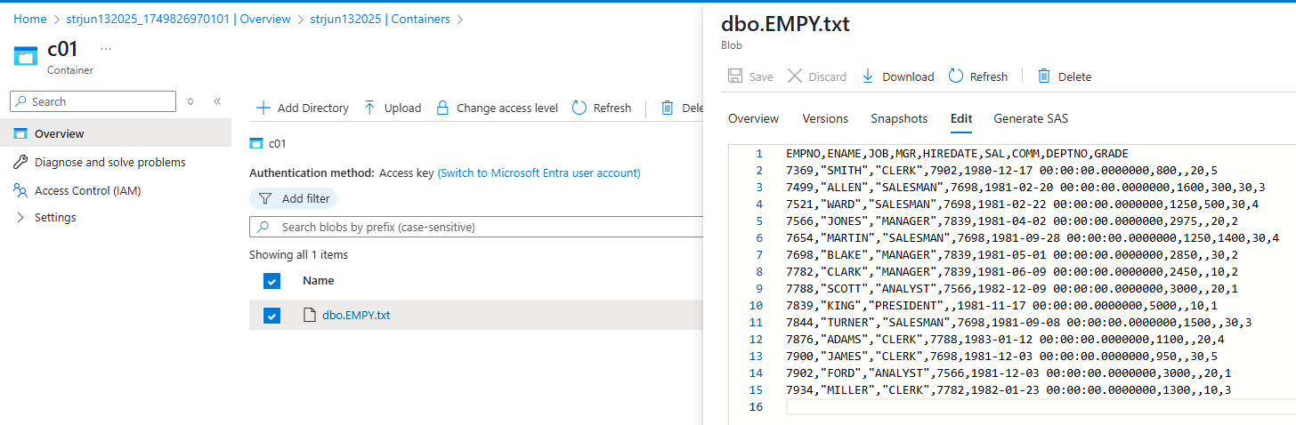

BLOB TO SQL COPY -- MULTIPLE INPUT FILE

---

parameter

1. COPY THE DATA FROM SERVER 1, DB 1, TABLE A TO SERVER 2, DB2, TABLE X

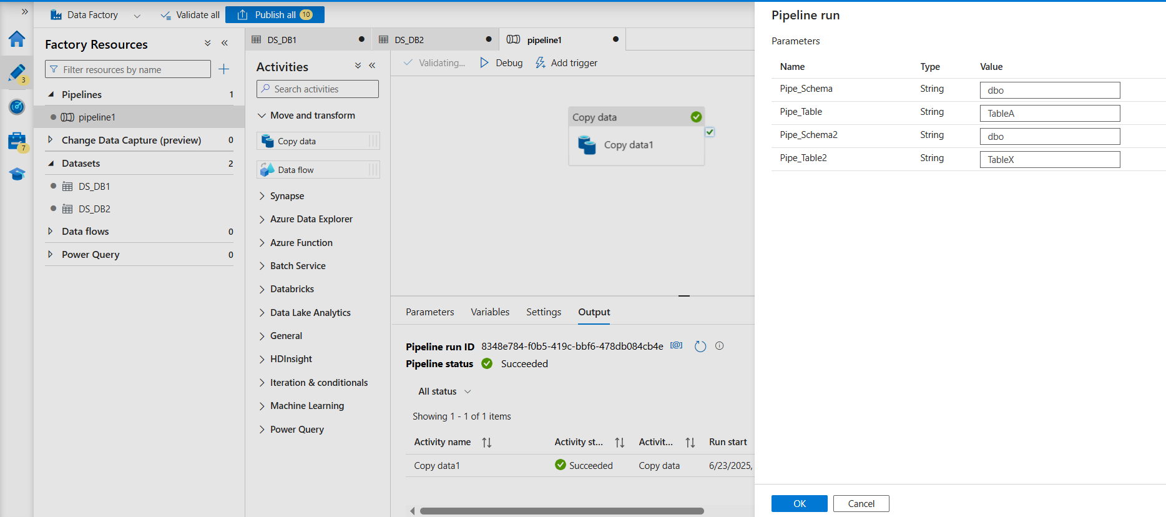

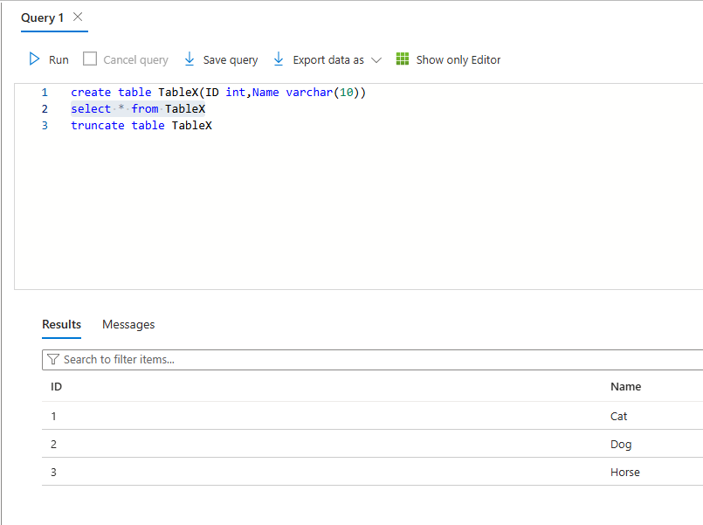

2. COPY THE DATA FROM SAME CONTAINER, FOLDER 1 TO FOLDER2

3. COPY THE DATA FROM CONTAINER1, FOLDER1 TO CONTAINER 2 FOLDER 2

4. COPY THE DATA FROM CONTAINER1, FOLDER1, FILE1 TO CONTAINER2, FOLDER2, FILE2

5. COPY THE DATA FROM ONE STORAGE ACCOUNT TO ANOTHER STORAGE ACCOUNT

For Employee database, please provide the max and min salary from each dept

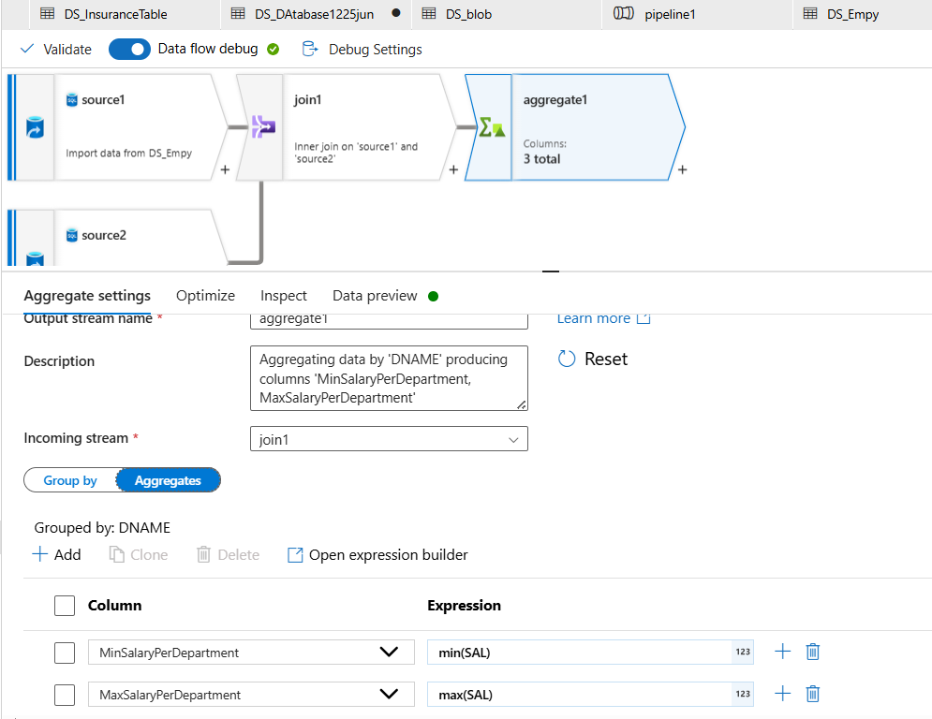

For Employee database, please provide if the current employee is above or below the dept wise average salary threshold

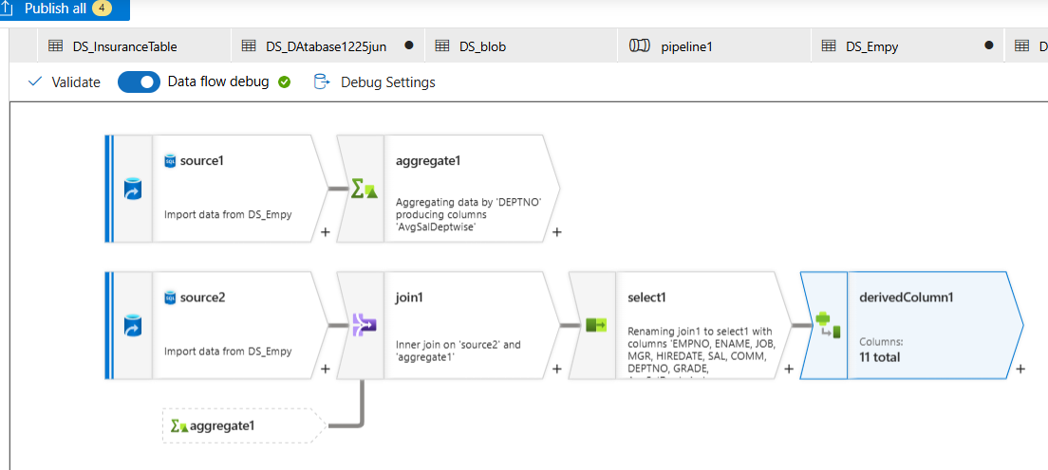

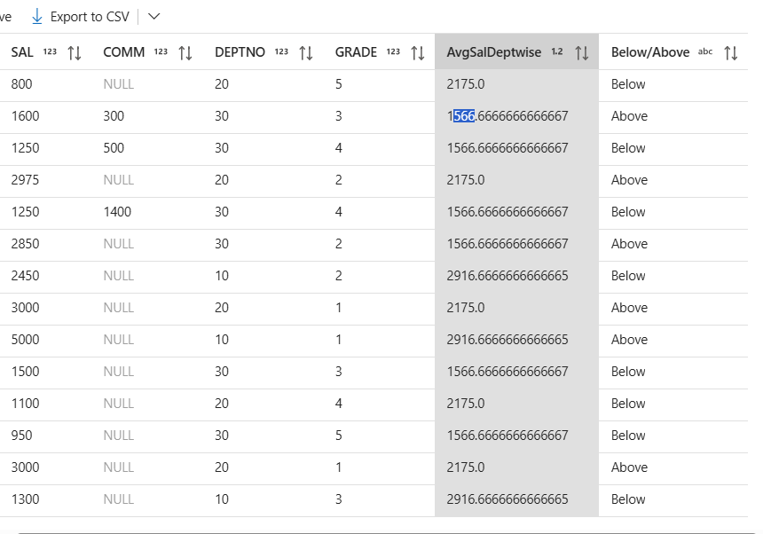

Join the employee and department dataset to get the total salary for department Executive and HR

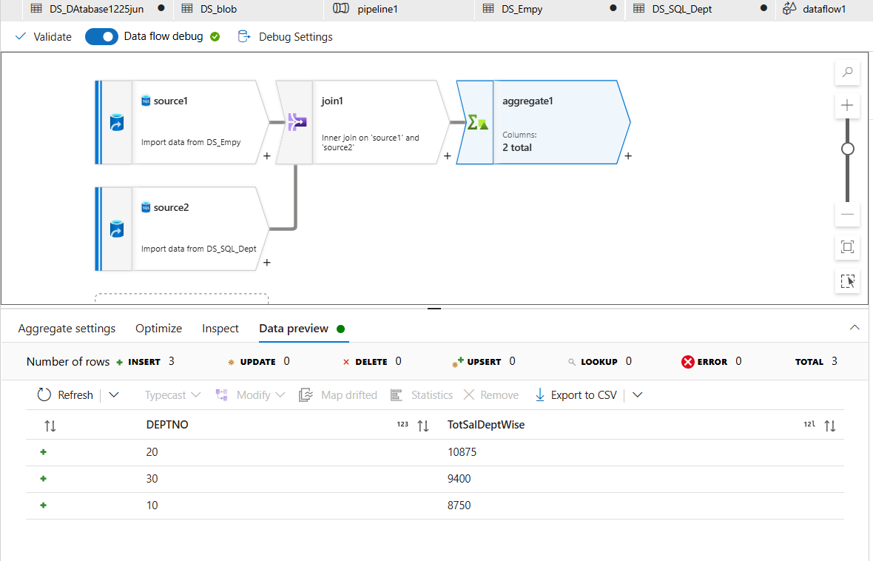

Append emp1,2,3 database

---

FOREACH ACTIVITY

Copy files from multiple databases to single database

Copy multiple db files to blob storage

Copy data from EMP_input database to EMP_Output database and Cust_Input database to Cust_Output database based on FOREACH activity.

IFACTIVITY

IF FILE EXISTS, THEN COPY THE DATA ELSE DONT COPY

IF DATABASE TABLE CONTAINS A DATA THEN COPY ELSE DONT COPY

IF BLOB INPUT CONTAINS A DATA THEN COPY ELSE DONT COPY

---

Switch Activity

CREATE TABLE ADDRESS_COMMON(NAME VARCHAR(20),ADDRESS VARCHAR(20),

MAILCODE VARCHAR(5), CITY VARCHAR(20), COUNTRY VARCHAR(20))

CREATE TABLE ADDRESS_INDIA(NAME VARCHAR(20),ADDRESS VARCHAR(20),

CITY VARCHAR(20), COUNTRY VARCHAR(20))

CREATE TABLE ADDRESS_USA(NAME VARCHAR(20),ADDRESS VARCHAR(20),

MAILCODE VARCHAR(5), CITY VARCHAR(20), COUNTRY VARCHAR(20))

CREATE TABLE ADDRESS_OTHERS(NAME VARCHAR(20),ADDRESS VARCHAR(20),

MAILCODE VARCHAR(5), CITY VARCHAR(20), COUNTRY VARCHAR(20))

INSERT INTO ADDRESS_COMMON(NAME, ADDRESS, MAILCODE, CITY, COUNTRY)

VALUES

('RAJ','123',NULL,'HYDERABAD','INDIA'),

('RAM','234',NULL,'HYDERABAD','INDIA'),

('MIKE','999','1000','ARIZONA','USA'),

('DUKE','888','2000','DC','USA'),

('ROBERT','788','1000','MANCHESTER','UK'),

('ALIA','688','3000','LONDON','UK')

SELECT * FROM ADDRESS_COMMON

Task1: Create address common with 6 different countries and anything which is not INDIA, UK, USA should go to the ADDRESS_OTHERCOUNTRIES database

Task2:

Dynamically create a pipeline which will identify the list of databases and clear of the records from the same. Data should clear only for TABLEA AND TABLE B and it should ignore table C and TABLE D

Database Name DELETE_RECORDS

TABLE_A Y

TABLE_B Y

TABLE_C N

TABLE_D N

TASK3:- DELETE THE SPECIFIC FORMAT FILES ONLY BASED ON THE FOLDER VALUE AND FILEFORMAT PROVIDED IN PARAMETER. Two Parameters --One Folder path/foldername, second fileformat

---

Task1:- Based on the last modified date of the blob storage, If the last modifide date is greater than the max transaction date of the Database, then copy the blob file, else no action.

Task2:- Create and set a variable value as ID based on the Max transaction date from iftable_output